

Designing

Designing is the most important phase of any software development. The design phase of software development deals with transforming the customer requirements as described in the SRS documents into a form implementable using a programming language. The designing is done with the help of UML(Unified Modeling Language) diagrams. Different types of UML diagrams are-

1.Use-case diagram

2. Activity diagram

3.E-R diagram

4.Sequence diagram

5.Class diagram

6. Data flow diagram

With the help of UML diagram designing of software is done.

UML diagram for canteen automation and management system are-

1. **USE-CASE DIAGRAM**

The Use case diagram is a graphic depiction of the interaction among the elements of Canteen management system.It represents the methodology used in system analysis to identify,clarify,and organize system requirements of Canteen Management System.The main actors of Canteen Management System in the use case diagram are: Admin ,System User,Employee,Anonymous Users,who perform the different type of use cases…

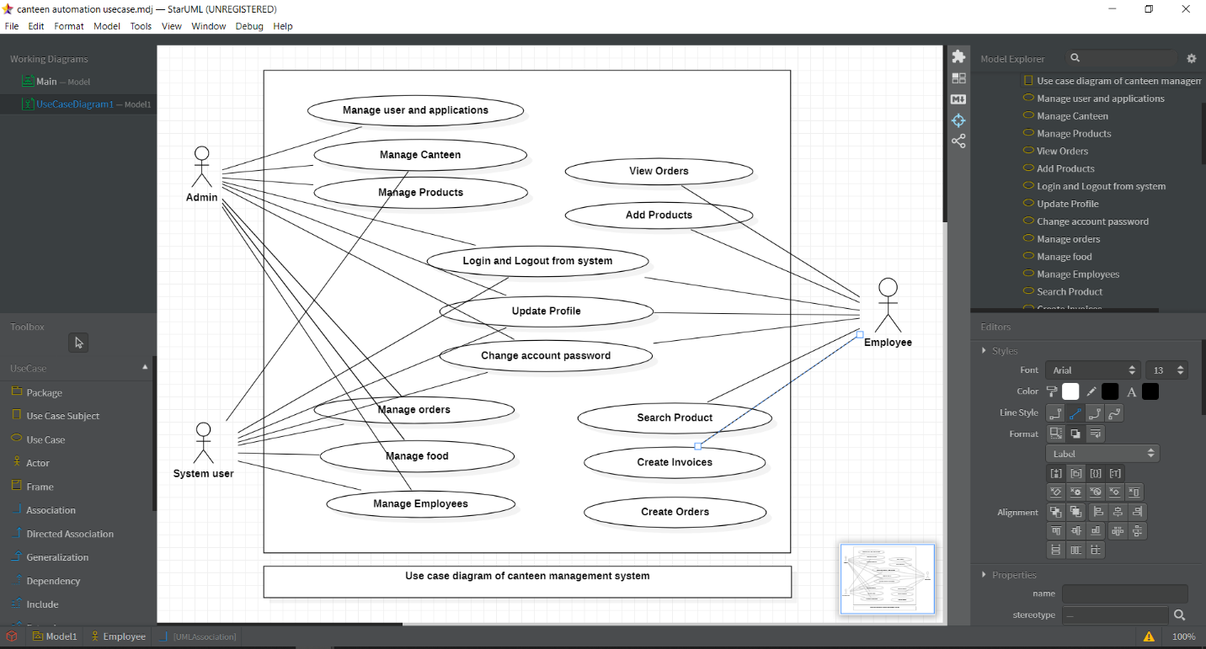

1. **ACTIVITY DIAGRAM**

This is the login activity diagram of Canteen management system,which shows the flows of the login activity , where admin will be able to login using their usernsme and password. After login user can manage all the operations on bill employee,food item , canteen , orders , products. All the pages such as canteen, orders,products are secure and user can access these pages after login.

